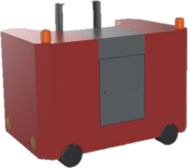

ADD

**skype**

**WhatsApp**

**E-mail**

|  |  |  |  |  |  |  |  |  |  |  |  |
| --- | --- | --- | --- | --- | --- | --- | --- | --- | --- | --- | --- |
| **website**  **Telephone**  T.S.I 501 | | | | | | | | | | | |
| **No.** | Type | **picture** | **Type** | **Unit** | | **Qty** |  | **Remarks** | | |
| **First** | Train. lecomotive,light rail cleaning equipment | | | | | | | | | | |
| 1  2  3 | train cleaning equipment  lecomotive cleaning equipment ligh rail cleaning equipment | | |
|
|
| 3 | Subtotal | | | | |
| **Second** | Risense "carwash cloud service" charges carwash cloud service charges  Subtotal | |  |  | |
| 1  2 |
|  | |
| **Third** | **Additional charges** | | | | | | | | | | |
| 1 | Special packing cost | | | | | | |
| 2 | materials inland transporation charges | |  |  | |
| 3 | **installation allowance** | |
| 4 | freight charges | |  |  | |  |
| 5 | insurance premium | |  |  | |  |  |  | |
| 6 | subtotal |  |  |  | |  |  |  | |
| Tenth | **Total project value (USD)** | |  |  | |  |  |  | |
|  |  | | |  | | |  | | | | |
| Third-III | **General Introductions** | | |  | | |  | | | | |
| 1 | Successful train cleaning equipment cases | |  |  | |  |  | | | | |
|  | Thailand |  | | | |  |  | | | | |
|  |  |  |  |
| 2 | Equipment parameter |  | |
|  |  |  |  |  | |
|  |  |  |  |
|  |  |  |  |  |
|  |  |  |  | 清 废 |
|  |  |  | |  |
|  |  |  |  |  |
|  |  |  |  |  |
|  |  |  | |
| 3 | Core components |  | |  | | | | |
| 3.1 | Walking hard - core configuration | | |  | | | | |
| 3.2 | first-class core components | | |  | | | | |
| 4 |  |  | |  | | | | |
| 4.1 |  |  | |  | | | | |
|  |  |  | |  | | | | |
|  |  |  | |  | | | | |
|  |  |  | |  | | | | |
|  |  |  | |  | | | | |
| 4.2 |  |  | |  | | | | |
|  |  |  | |  | | | | |



|  |  |  |  |  |  |  |  |  |  |  |  |  |  |  |
| --- | --- | --- | --- | --- | --- | --- | --- | --- | --- | --- | --- | --- | --- | --- |
|  |  |  | | | | | | |  | | | | | |
|  |  |  | | | | | | |  | | | | | |
|  |  |  | | | | | | |  | | | | | |
|  |  |  | | | | | | |  | | | | | |
| 4.3 |  |  | | | | | | |  | | | | | |
|  |  |  | | | | | | |  | | | | | |
|  |  |  | | | | | | |  | | | | | |
|  |  |  | | | | | | |  | | | | | |
| 5 | **innovative design & Functions** | | | | | | | |  | | | | | |
| 5.1 | innovative design |  | | | | | | |  | | | | | |
|  |  | | | | | | | | | | | | | | | | |
|  |
|  |
|  |
|  |
|  |
|  |
|  |
|  |
|  |
|  |
|  |
|  |
|  |
|  |
|  |
|  |
|  |
|  |
|  | | |  |  | | |  |  | |  | |
|  | | |  |  | |  |  |  | |  | |
|  |
|  |
|  |
|  |
|  |
|  |
|  |
|  |
|  |
|  |
|  |
|  |
|  |
|  |
|  |  |  | | |  | | | |  | |  | |  |  | |  |  |
|  |  |  | | |  | | | |  | |  | |  |  | |  |  |
|  |  |  | | |  | | | |  | |  | |  |  | |  |  |
|  |  | | | | | | | | | | | | | | | | |
|  |  |  | | |  | | | |  | |  | |  |  | |  |  |
|  |  |  | | |  | | | |  | |  | |  |  | |  |  |
|  |  |  | | |  | | | |  | |  | |  |  | |  |  |
|  |  |  | | |  | | | |  | |  | |  |  | |  |  |
|  |  |  | | |  | | | |  | |  | |  |  | |  |  |
|  |  |  | | |  | | | |  | |  | |  |  | |  |  |
|  |  |  | | |  | | | |  | |  | |  |  | |  |  |
|  |  | | | | | | | | | | | | | | | | |
|  |  |  | | | | | | | | | | |  |  | |  |  |
|  |  |  | | | | | | | | | | |  |  | |  |  |
|  |  |  | | | | | | | | | | |  |  | |  |  |
|  |  |  | | | | | | | | | | |  |  | |  |  |
|  |  |  | | | | | | | | | | |  |  | |  |  |
|  |  |  | | | | | | | | | | |  |  | |  |  |
|  |  |  | | | | | | | | | | |  |  | |  |  |
|  |  |  | | | | | | | | | | |  |  | |  |  |

|  |  |  |  |  |  |  |  |  |  |
| --- | --- | --- | --- | --- | --- | --- | --- | --- | --- |
|  |  |  | | | |  |  |  |  |
|  |  |  | | | |  |  |  |  |
|  |  |  | | | |  |  |  |  |
|  |  |  |  |  |  |  |  |  |  |
|  |  |  | | | |  | | | |
|  |  |  |  |  |  |  |  |  |  |
|  |  |  |  |  |  |  |  |  |  |
|  |  |  |  |  |  |  |  |  |  |
|  |  |  |  |  |  |  |  |  |  |
|  |  |  |  |  |  |  |  |  |  |
|  |  |  |  |  |  |  |  |  |  |
|  |  |  |  |  |  |  |  |  |  |
|  |  |  |  |  |  |  |  |  |  |
|  |  |  |  |  |  |  |  |  |  |
|  |  |  |  |  |  |  |  |  |  |
|  |  |  |  |  |  |  |  |  |  |
|  |  |  |  |  |  |  |  |  |  |
|  |  |  |  |  |  |  |  |  |  |
|  |  |  |  |  |  |  |  |  |  |
|  |  |  |  |  |  |  |  |  |  |
|  |  |  |  |  |  |  |  |  |  |
|  |  |  |  |  |  |  |  |  |  |
|  |  |  |  |  |  |  |  |  |  |
|  |  |  |  |  |  |  |  |  |  |
|  |  |  |  |  |  |  |  |  |  |
|  |  |  |  |  |  |  |  |  |  |
|  |  |  |  |  |  |  |  |  |  |
|  | | | | | | | | | |

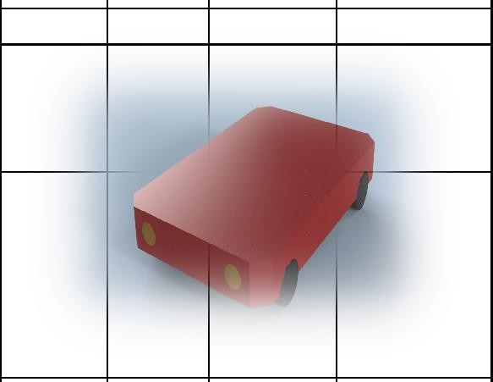

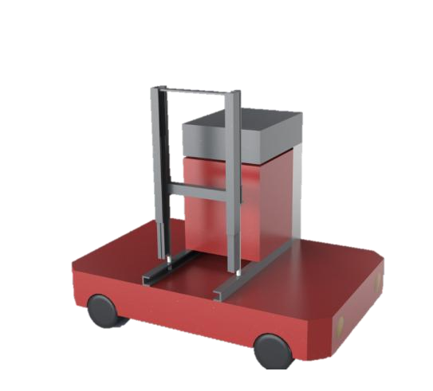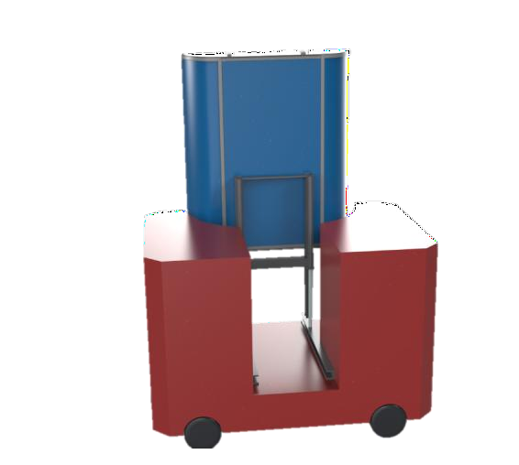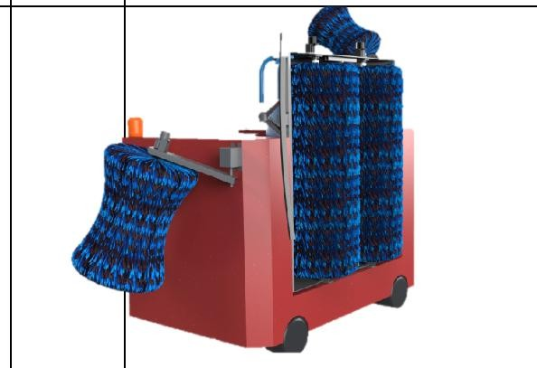

ADD

**skype**

**WhatsApp**

**E-mail**

|  |  |  |  |  |  |  |  |  |  |  |  |  |  |  |  |  |  |  |  |  |  |  |  |
| --- | --- | --- | --- | --- | --- | --- | --- | --- | --- | --- | --- | --- | --- | --- | --- | --- | --- | --- | --- | --- | --- | --- | --- |
| **website**  **Telephone**  T.S.I 501 | | | | | | | | | | | | | | | | | | | | | | | |
| **No.** | Type | | **picture** | | **Type** | | **Unit** | | | **Qty** | | | | **Remarks** | | | |
| 5.2 | Functions | |  | |  | |  | | | | |  | | | |  | | |  | | |
| a0 |  | |  | |  | |  | |  | | |  | | | |  | | |  | | |
|  |  | | | | | | | | | | | | | | | | | | | | | | |
|  |
|  |
|  |
|  |
|  |
|  |
|  |
|  |
|  |
|  |
|  |
|  |
|  |
|  |
|  |  | |  | |  | |  | | |  | | | |  | | |  | | | |  | |  |
| a1 |  | |  | |  | |  | |  | | |  | | | |  | | |  | | |
|  |  | | | | | |  |  | | |  | | | |  | | | | |
|  |  |  | | |  | | | |  | | | | |
|  |  |  | | |  | | | |  | | | | |
|  |  |  | | |  | | | |  | | | | |
| a2. |  | |  | |  | |  |  | | |  | | | |  | | | | |
|  |  | | | | | |  |  | | |  | | | |  | | | | |
|  |  |  | |
|  |  | |  | |  |  | | | | | | |
| a3. |  | |  | |  | |  | | |  | | | | | | |  | | | |  | |  |
|  | The top profile lifting high-pressure water can automatically rise and fall along the roof streamline,  and maintain a certain inclination, so that the high-pressure water washing capacity is doubled. | | | | | | | | | | | | | | | | | | | | | | |

使

|  |  |  |  |  |  |  |  |  |  |  |  |  |  |  |  |  |  |  |  |  |  |  |  |  |  |  |  |  |  |  |  |
| --- | --- | --- | --- | --- | --- | --- | --- | --- | --- | --- | --- | --- | --- | --- | --- | --- | --- | --- | --- | --- | --- | --- | --- | --- | --- | --- | --- | --- | --- | --- | --- |
|  | |  | | | |  | | | | | | | | | | | | | | | | | | | | | | | | | |
|  | | | | | | | | | | | | | | | | | | | | | | | | | | | |
|  | | | | | | | | |
|  | | | | | | | | |
|  | | | | | | |  | |  | |  | |  | | |  | | | | |
|  |  | |  | |  | | |
|  | | | | | | |  | |  | |  | |  | | |  | | | | |
|  |  | |  | |  | | |
|  | | | | | | |  | |  | |  | |  | | |  | | | | |
|  | |  | | | | | | | | | | | | | | |  | | |  | |  | | |  | | | | |
|  | |  | | | |  | | | | | |  | | | | |  | | |  | |  | | |  | | | | |
|  | | | |  | | | | | |  | | | |  |  | | | |  | | | |  | | |
|  | | | | | | |  | |  | |  | |  | | |  | | | | |
|  | | | |  | | | | | |  | | | |  |  | | | |  | | | |  | | |
|  | | | |  | | | | | |  | | | |  |  | | | |  | | | |  | | |
|  | | | |  | | | | | |  | | | |  |  | | | |  | | | |  | | |
|  | | | |  | | | | | |  | | | |  |  | | | |  | | | |  | | |
|  | | | |  | | | | | |  | | | |  |  | | | |  | | | |  | | |
|  | | | |  | | | | | |  | | | |  |  | | | |  | | | |  | | |
|  | | | |  | | | | | |  | | | |  |  | | | |  | | | |  | | |
|  | | | |  | | | | | |  | | | |  | | | |
|  | |  | | | |  | | | | | |  | | | | |  | | |  | |  | | |  | | | | |
|  | |  | | | |  | | | | | |  | | | | |  | | | |  | | |  | | |  | |  | |  |



|  |  |  |  |  |  |  |  |  |  |  |  |  |  |  |  |  |  |  |  |  |  |  |  |  |  |  |  |
| --- | --- | --- | --- | --- | --- | --- | --- | --- | --- | --- | --- | --- | --- | --- | --- | --- | --- | --- | --- | --- | --- | --- | --- | --- | --- | --- | --- |
|  | |  | |  | |  | | |  | | | | |  | | | | |  | | | |  | | | | |
|  | |  | |  | |  |  | | | | |  | | | | | |  | | | | | |
|  | |  | |  | |  | | | | | | | | | |  | | | |  | | | | |  | | | | |  | |
|  | |  | |  | |  |  | | | | |  | | | | | |  | | | | | |
|  | |  | |  | |  |  | | | | |  | | | | | |  | | | | | |
|  |  | |  | |  | | |  | | | | |  | | | |  | | | | |  | | | | |
|  |  | |  | |  | | |  | | | | | | | | | | | | |  | | | | |  | | |  | |  | |
|  | |  | |  | |  | | | |
|  | |  | |  | |
|  | |  | |  | |  | | | | |  | | | | |  | | | |  | | | | |  | | | | |  | |
|  | |  | |  | |  | | | | |  | | | | |  | | | |  | | | | |  | | | | |  | |
|  | |  | |  | |  | | | | |  | | | | |  | | | |  | | | | |  | | | | |  | |
|  | |  | |  | |  | | | | |  | | | | |  | | | |  | | | | |  | | | | |  | |
|  | |  | |  | |  | | |  | | | | |  | | | | |  | | | |  | | | | |
|  | |  | | | |  |  | | | | |  | | | | | |  | | | | | |
|  | |  | |  | |  | | | | |  | | | | |  | | | |  | | | | |  | | | | |  | |
|  | |  | |  | |  | | | | |  | | | | |  | | | |  | | | | |  | | | | |  | |
|  | |  | |  | |  | | | | |  | | | | |  | | | |  | | | | |  | | | | |  | |
|  | |  | |  | |  | | |  | | | | |  | | | | |  | | | |  | | | | |
|  | |  | | | |  |  | | | | | | | | | | |  | | | | | |
|  | |  | |  | |  | | |  | | | | |  | | | | |  | | | |  | | | | |
|  | |  | |  | |  |  | | | | |  | | | | | |  | | | | | |
|  | |  | |  | |  | | |  | | | | |  | | | | |  | | | |  | | | | |
|  | |  | |  | |  |  | | | | |  | | | | | |  | | | | | |
|  |  | |  | |  | | |  | | | | |  | | | |  | | | | |  | | | | |
|  |  | |  | |  | | |  | | | | | | |  | | | | | |  | | | | |  | | |  | |  | |
|  |  | |  | |  | | |  | | | | | | |  | | | | | |  | | | | |  | | |  | |  | |
|  |  | | | | | | | | | | | | | | | | | | | | | | | | | | | | | | | |
|  |  | |  | | | | | | | | | | | | | | | | | |  | | | | |  | | |  | |  | |
|  |  | |  | | | | | | | | | | | | | | | | | |  | | | | |  | | |  | |  | |
|  |  | |  | | | | | | | | | | | | | | | | | |  | | | | |  | | |  | |  | |
|  |  | |  | | | | |  | | | | | | |  | | | | | |  | | | | |  | | |  | |  | |
|  |  | |  | | | | | | | | | | | | | | | | | |  | | | | |  | | |  | |  | |
|  |  | |  | | | | | | | | | | | | | | | | | |  | | | | |  | | |  | |  | |
|  |  | |  | | | | | | | | | | | | | | | | | |  | | | | |  | | |  | |  | |
|  |  | |  | | | | | | | | | | | | | | | | | |  | | | | |  | | |  | |  | |
|  |  | |  | | | | | | | | | | | | | | | | | |  | | | | |  | | |  | |  | |
|  |  | |  | | | | | | | | | | | | | | | | | |  | | | | |  | | |  | |  | |
|  |  | |  | | | | | | | | | | | | | | | | | |  | | | | |  | | |  | |  | |
|  |  | |  | |  | | |  | | | | | | |  | | | | | |  | | | | |  | | |  | |  | |
|  |  | |  | | | | | | | | | | | | | | | | | |  | | | | | | | | | | | |
|  |  | |  | |  | | |  | | | | | | |  | | | | | |  | | | | |  | | |  | |  | |
|  |  | |  | |  | | |  | | | | | | |  | | | | | |  | | | | |  | | |  | |  | |
|  |  | |  | |  | | |  | | | | | | |  | | | | | |  | | | | |  | | |  | |  | |
|  |  | |  | |  | | |  | | | | | | |  | | | | | |  | | | | |  | | |  | |  | |
|  |  | |  | |  | | |  | | | | | | |  | | | | | |  | | | | |  | | |  | |  | |
|  |  | |  | |  | | |  | | | | | | |  | | | | | |  | | | | |  | | |  | |  | |
|  |  | |  | |  | | |  | | | | | | |  | | | | | |  | | | | |  | | |  | |  | |
|  |  | |  | |  | | |  | | | | | | |  | | | | | |  | | | | |  | | |  | |  | |

|  |  |  |  |  |  |  |  |  |  |
| --- | --- | --- | --- | --- | --- | --- | --- | --- | --- |
|  |  |  |  |  |  |  |  |  |  |
|  |  |  |  |  |  |  |  |  |  |
|  |  |  |  |  |  |  |  |  |  |
|  |  |  |  |  |  |  |  |  |  |
|  |  |  |  |  |  |  |  |  |  |
|  |  |  |  |  |  |  |  |  |  |
|  |  |  |  |  |  |  |  |  |  |
|  |  |  |  |  |  |  |  |  |  |
|  |  |  |  |  |  |  |  |  |  |
|  |  |  |  |  |  |  |  |  |  |
|  |  |  |  |  |  |  |  |  |  |
|  |  |  |  |  |  |  |  |  |  |
|  |  |  |  |  |  |  |  |  |  |
|  |  |  |  |  |  |  |  |  |  |
|  | | | | | | | | | |